Kidz World

By

Navdeep

Level-6

Final Project

Table of Contents

Project Proposal 3

Goals and Objectives 3

Project Scope 3

Project Specifications 3

Target Audience 3

Project Deliverables 4

Resource Requirements 4

Project Tasks and Milestones 4

Project Assumptions 5

Project Report 5

Detail Design 6

Home Page 6

Registration Page 6

Login Page 7

Age Admin View 7

Sellers Admin View 8

Toys Admin View 8

All Toys Visitor View 9

View Sellers Visitor View 9

Project Testing 10

User Manual 10

Summary 10

System Configuration 10

User Access Levels 10

# 

# Project Proposal

## Goals and Objectives

The main goal or aim of the project is to implement an online web application named “Kidz World”. The main purpose of the application is help people to get toys for their kids according to the age group specified. In this application there are two types of users- admin and registered visitor. Admin has different functionalities as compare to registered visitor. Admin can add, edit, delete and check details of all age groups, all sellers and toys.

## Project Scope

The scope of this project is to implement an app named “Kidz World” with the help of which user can find any age groups, seller as well as toys of different ages. The duration of the project is 20 working days which is equals to 4 weeks.

## Project Specifications

* Admin login/logout
* Add, edit, delete and check details of sellers and toys by admin.
* Admin can delete, edit and check age groups.
* Admin can register new admins.
* Registered Visitor can login/logout.
* New Visitor can register.
* Visitor can view age groups, sellers and toys.

## Target Audience

The target audience for this project is the customer who like explore the toys for their children according to the age groups specified. The age can go from 10 plus to 50 plus.

## Project Deliverables

The deliverables of the project are:

|  |  |
| --- | --- |
| **Deliverable** | **Description** |
| Final Report | This will be the final report of the project. |
| Coding | The executable code of the project will go under this. |
| Documentation | This portrays the documentation of the project. |
| Testing | All the test details will be covered in this part. |

## Resource Requirements

* Windows Operating System.
* Microsoft word for documentation.
* Asp.net MVC Framework
* 64-bit Processor and 6 GB or more RAM
* Identity framework- ASP

## Project Tasks and Milestones

|  |  |  |  |  |
| --- | --- | --- | --- | --- |
| **Tasks** | **Week-1** | **Week-2** | **Week-3** | **Week-4** |
| Brainstorming and analysis |  |  |  |  |
| Planning and initial meeting Project Proposal document. |  |  |  |  |
| Database Design and UI Design |  |  |  |  |
| Identity framework implementation |  |  |  |  |
| Coding for admin and reporter |  |  |  |  |
| Testing |  |  |  |  |
| Final Documentation and closing |  |  |  |  |

## Project Assumptions

Following are the assumption made while implementing the project:

* One admin and registered visitor will be registered by default.
* Application will be free and open source.

# Project Report

#### Functional and Non-Functional

|  |  |
| --- | --- |
| Users | Functional |
| Admin | * Login/logout * Register new admins * Admin can add, edit, delete, check details for Ages. * Admin can edit, delete and check details for sellers and Toys details. |
| Customer | * Can view details of ages and their toys. * Can view the details of sellers. * New customers can register for free. * Login using valid credentials |
|  | Non- Functional |
|  | * High speed * Fast Loading time * High performance and security * All browsers compatibility. |

## Detail Design

### 

### Home Page

The main landing page of the application. On navigation bar options are- Home, All Toys, Register, Login.

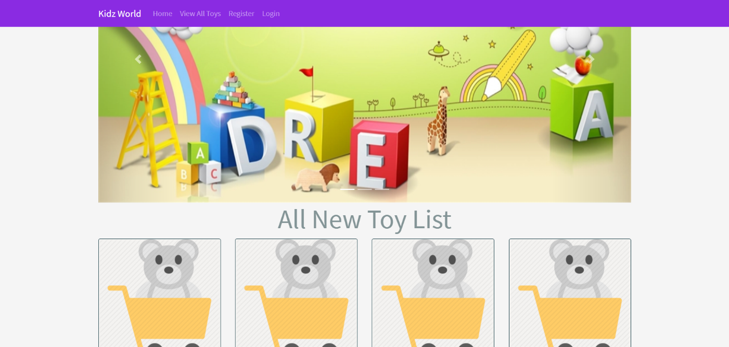

### 

### Registration Page

With the help of this page, new registered visitor can sign up for the app

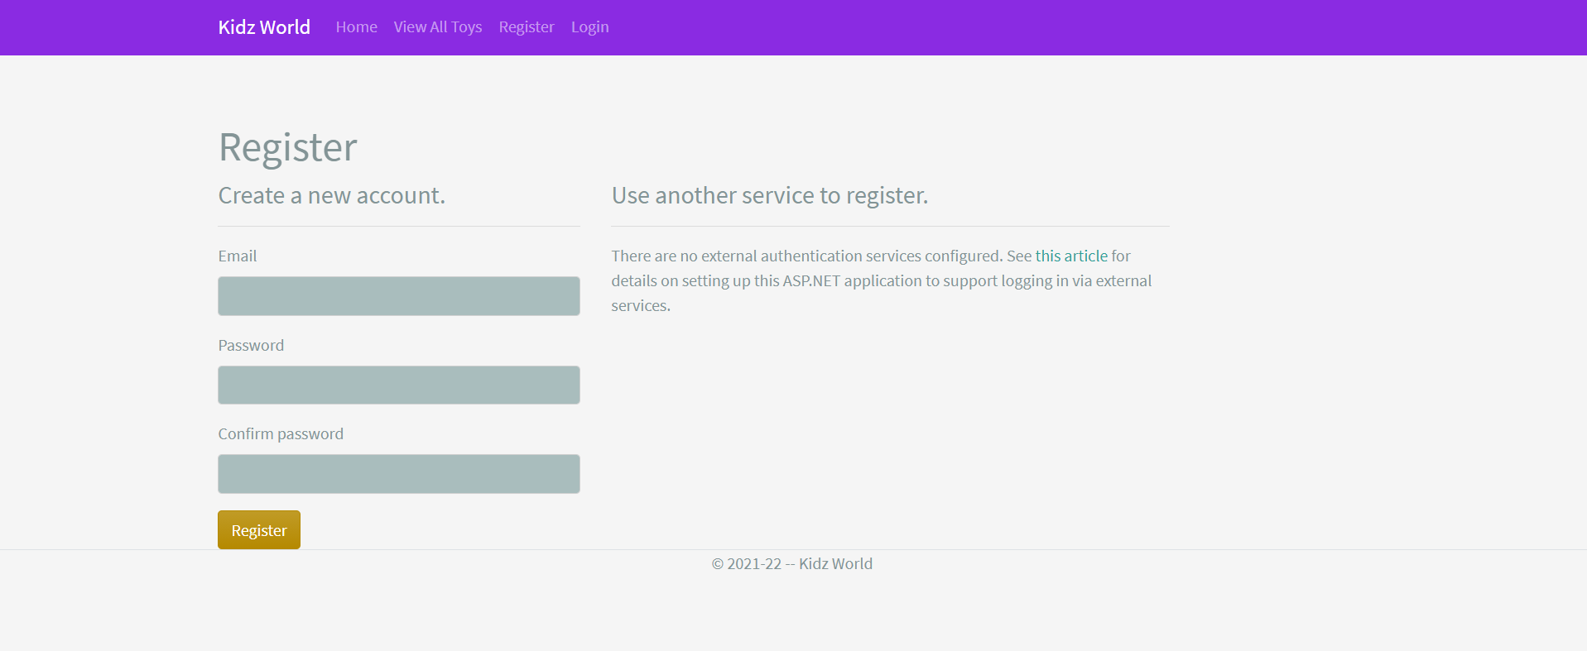

### 

### Login Page

With the help of this page, registered visitor and admin can login to the application using their valid credentials.

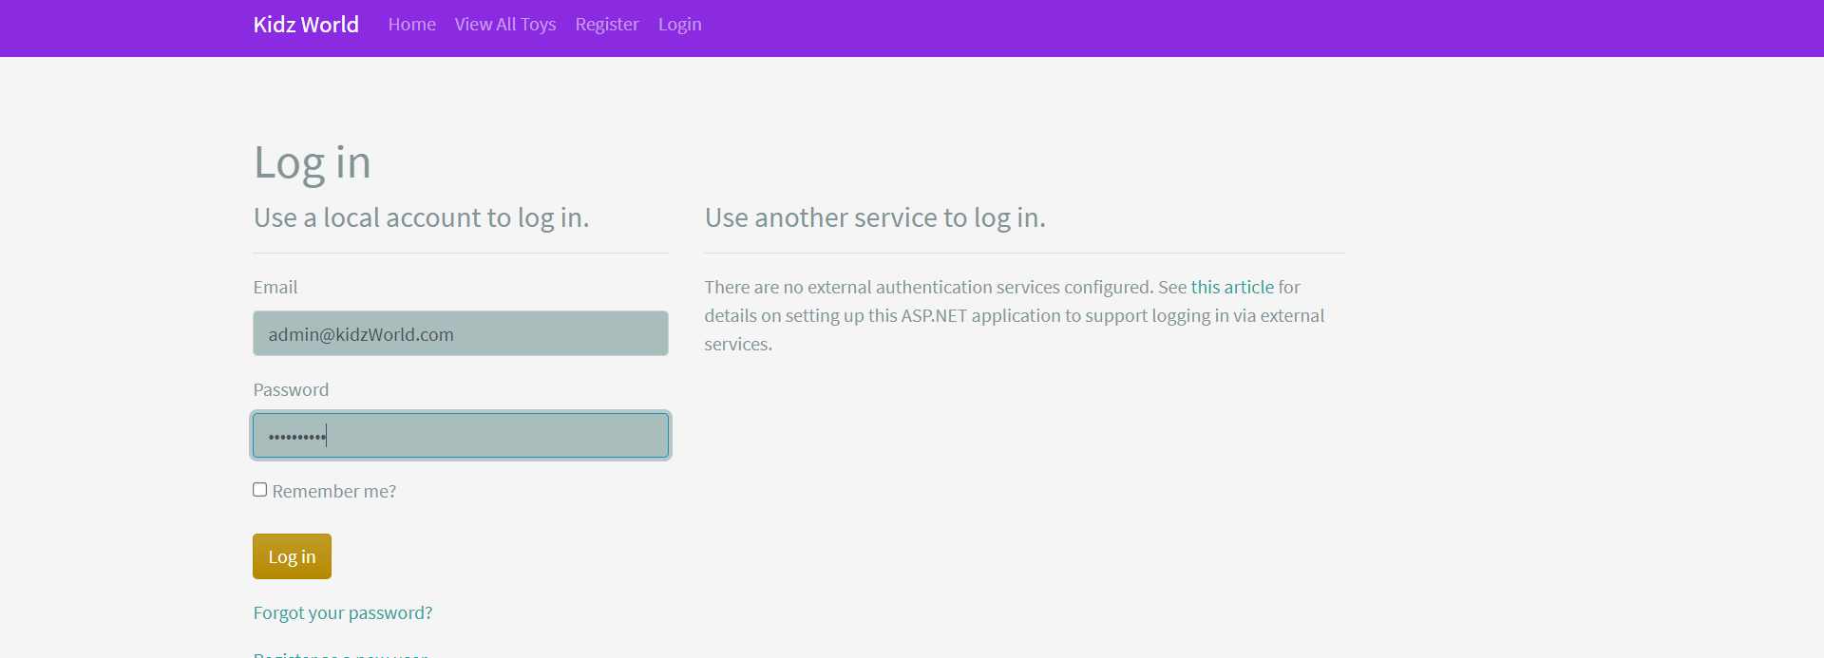

### 

### Ages Admin View

This page highlights all the Age groups available on the application. Admin can add new Age group, edit, delete and check details of the existing ones.

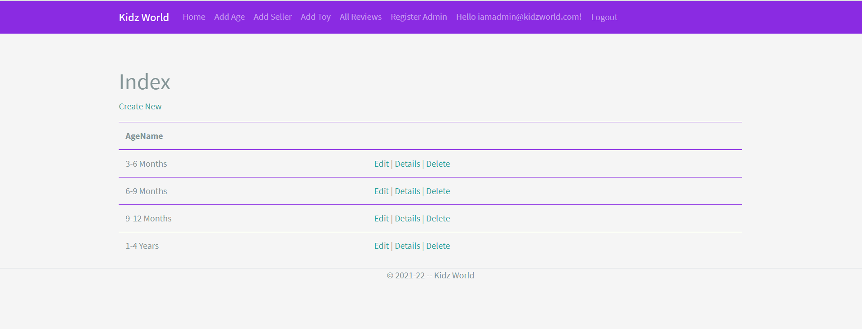

### Sellers Admin View

With the help of this page admin can manage the Seller details by editing, deleting and checking their details.

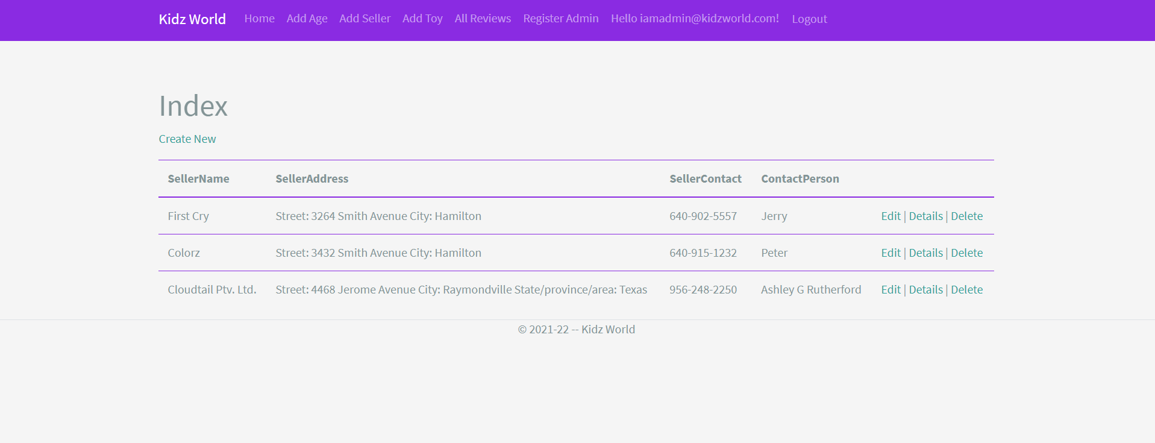

### 

### Toys Admin View

With the help of this page Admin can view, add, edit and delete Toys Details.

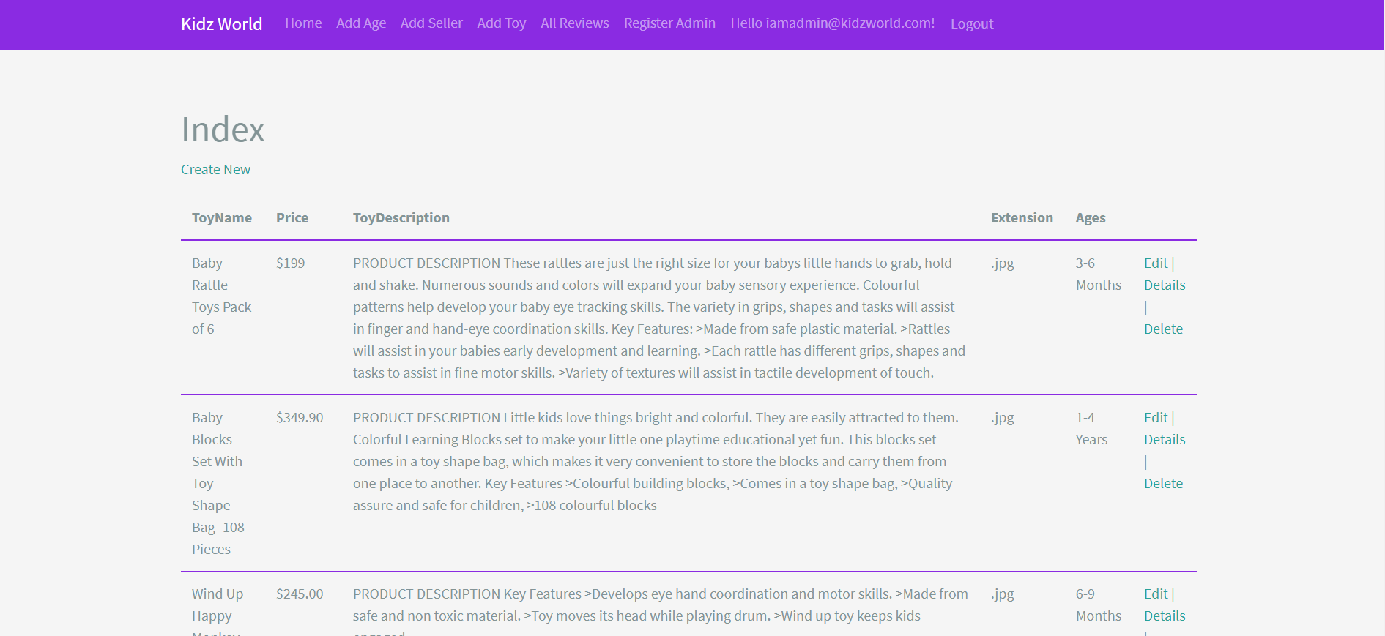

### Toys Visitor View

With the help of this page visitor can check the details of the Products.

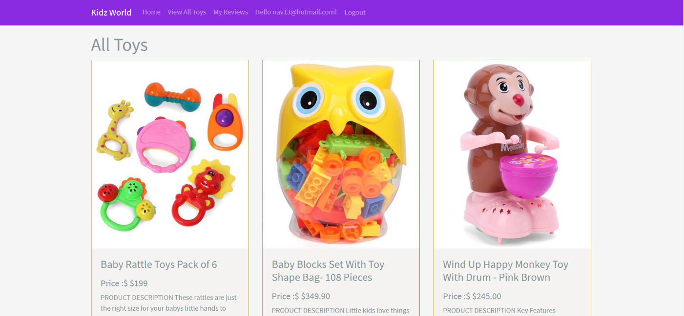

### Sellers Visitor View

This page shows the Supplier Registered View

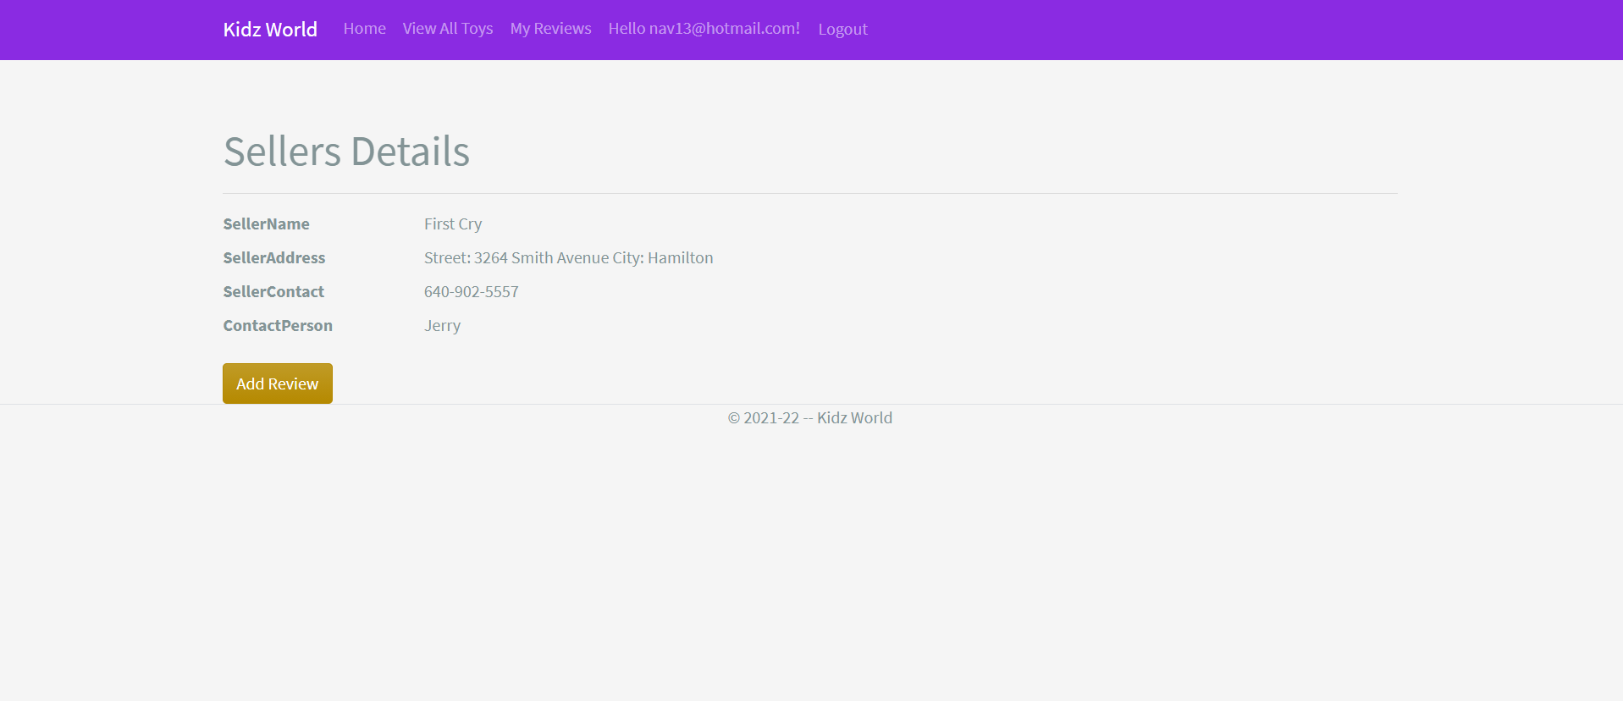

## 

## Project Testing

The testing file for usability testing is attached as [usability test.xlsx](usability%20test.xlsx)

# User Manual

The main purpose of the application Kidz World is to help people to find toys for their kids according to the age group specified. In this application there are two types of users- admin and registered user or visitor customer. Admin has different functionalities as compare to customers. Admin can add, edit, delete and check details of toys. Admin can edit, delete and check details of the sellers and toys. Also, registered user have authority to view toys seller’s details.

## Summary

### System Configuration

This app will be useful to for distributing information of toys and their seller details in presentable format.

### User Access Levels

Only registered users can access the features of this application.

* **Admin:** Admin has full access of the app can register new admins.
* **Registered Visitor:** New visitor can register and existing can login using their own credentials. They have limited access.